[UCanAccess](http://ucanaccess.sourceforge.net/site.html) is a pure Java JDBC driver that allows us to read from and write to Access databases without using ODBC. It uses two other packages, [Jackcess](http://jackcess.sourceforge.net/) and [HSQLDB](http://hsqldb.org/), to perform these tasks. The following is a brief overview of how to get it set up.

**Option 1: Using Maven**

If your project uses [Maven](https://maven.apache.org/index.html) you can simply include UCanAccess via the following coordinates:

**groupId:** net.sf.ucanaccess  
**artifactId:** ucanaccess

**Option 2: Manually adding the JARs to your project**

As mentioned above, UCanAccess requires Jackcess and HSQLDB. Jackcess in turn has its own [dependencies](http://jackcess.sourceforge.net/dependencies.html). So to use UCanAccess you will need to include the following components:

[UCanAccess](http://ucanaccess.sourceforge.net/site.html) (ucanaccess-x.x.x.jar)  
[HSQLDB](http://hsqldb.org/) (hsqldb.jar, version 2.2.5 or newer)  
[Jackcess](http://jackcess.sourceforge.net/) (jackcess-2.x.x.jar)  
[commons-lang](http://commons.apache.org/proper/commons-lang/) (commons-lang-2.6.jar, or newer **2.x version**)  
[commons-logging](http://commons.apache.org/proper/commons-logging/) (commons-logging-1.1.1.jar, or newer **1.x version**)

Fortunately, UCanAccess includes all of the required JAR files in its distribution file. When you unzip it you will see something like

ucanaccess-4.0.1.jar

/lib/

commons-lang-2.6.jar

commons-logging-1.1.1.jar

hsqldb.jar

jackcess-2.1.6.jar

All you need to do is add all **five (5)** JARs to your project.

NOTE: Do **not** add loader/ucanload.jar to your build path if you are adding the other five (5) JAR files. The UcanloadDriver class is only used in special circumstances and requires a different setup. See the related answer [here](https://stackoverflow.com/a/34469789/2144390) for details.

**Eclipse:** Right-click the project in Package Explorer and choose Build Path > Configure Build Path.... Click the "Add External JARs..." button to add each of the five (5) JARs. When you are finished your Java Build Path should look something like this

[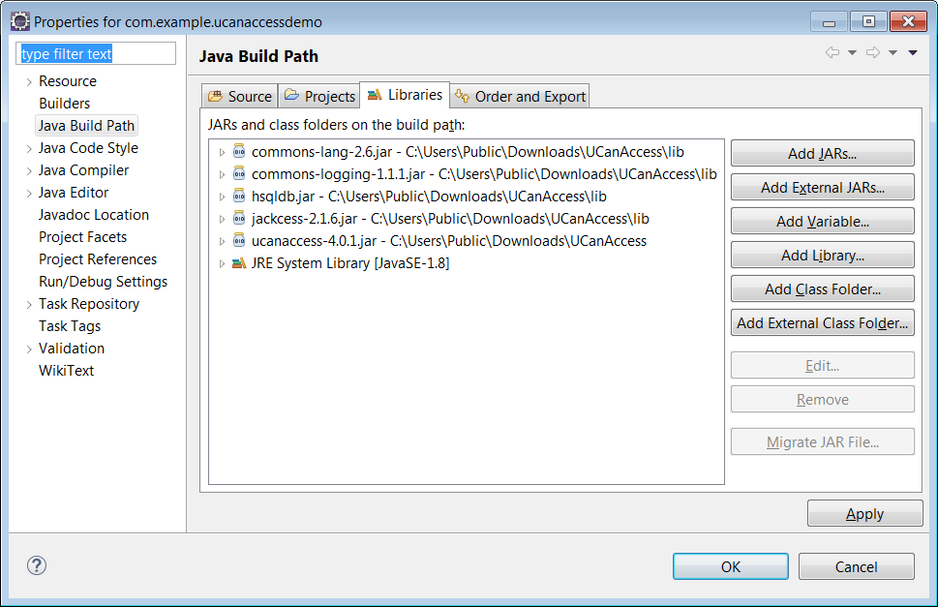](https://i.stack.imgur.com/uZOjj.png)

**NetBeans:** Expand the tree view for your project, right-click the "Libraries" folder and choose "Add JAR/Folder...", then browse to the JAR file.

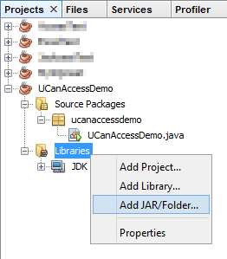

After adding all five (5) JAR files the "Libraries" folder should look something like this:

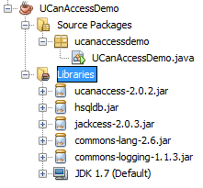

**IntelliJ IDEA:** Choose File > Project Structure... from the main menu. In the "Libraries" pane click the "Add" (+) button and add the five (5) JAR files. Once that is done the project should look something like this:

[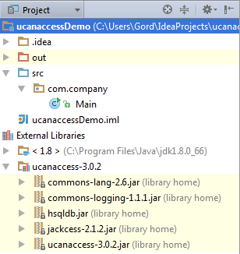](https://i.stack.imgur.com/AnOp5.png)

**That's it!**

Now "U Can Access" data in .accdb and .mdb files using code like this

// assumes...

// import java.sql.*;

Connection conn=DriverManager.getConnection(

"jdbc:ucanaccess://C:/__tmp/test/zzz.accdb");

Statement s = conn.createStatement();

ResultSet rs = s.executeQuery("SELECT [LastName] FROM [Clients]");

while (rs.next()) {

System.out.println(rs.getString(1));

}